2023 multicultural project
Our history in flags
The town of Wagin, originally called Wagin Lake was founded in 1889 following the completion of the Great Southern Railway. In 1898 Wagin was proclaimed a town with the word Lake being dropped.
In early 1898 the population of the town was 175: 125 men and 50 women. In 2021 the population had grown to 1761: 880 men and 881 women.
Wagin was originally a railway station for the surrounding wheat and sheep properties. It was created out of the combination of grain silos, bulk loading facilities and a rail link. Today the town's economic base has expanded to include barley, oats, lupins, canola, and cattle.
There is some debate around the Noongar word "Wagin" with it either meaning 'the place where emus watered' or a variation of a word pronounced 'wedge-an' which was simply a word for 'emu'.
Aboriginal people, the Noongar, have lived here since creation times. A big part of the noongar people’s culture is the Waugal, or great serpent. Noongar people believe that the Waugal dominates the earth and the sky and makes the Kaoondarnangor (thunder), Babanginy (lightening), and Boroong (rain). During the Nyitting, it created fresh waterways such as the Bilya/Beelier (river), Pinjar (swamps/lakes) and gamma (waterhole).
Settlement by Europeans has only occurred within the last 150 years.
The integration of a vast array of cultures and peoples during this 150-year period has resulted in the town, the people, the culture and the environment that you see today when traveling through Wagin.
Our recognition of this diversity has been achieved with the use of flags to represent the many countries and cultures that have contributed to the development of Wagin during this time.
Please celebrate with us as you walk the path and identify each flag. Should you yourself have arrived from one of these represented nations we thank you for the skills and efforts you have contributed to the development of what is our great country, Australia

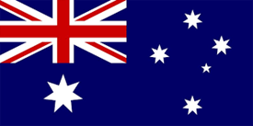
Australia
“G’Day Mate!”
Australia was founded 1st January 1901. Australia, officially the Commonwealth of Australia, is a sovereign country comprising the mainland of the Australian continent, the island of Tasmania, and numerous smaller islands. With an area of 7,617,930 square kilometres 2,941,300 sq mi), with an approximate population of 25.9 million. Australia is the largest country by area in Oceania and the world's sixth-largest country. Australia is the oldest, flattest, and driest inhabited continent, with the least fertile soils.
Australia is one of the most popular tourism destinations in the world. Due to its spectacular and diverse beauty, from the Great Barrier Reef, to the break taking beaches on the West Coast, Whale Sharks at Ningaloo, the spectacular rain forests and the amazing Bungle Bungles in the top end, not forgetting the beautiful scenery of Tasmania. Australia is definitely the wonder from Down Under.

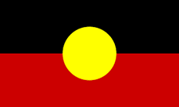
Aboriginal
” Kaya”
The colours of the Aboriginal flag represent the First nations people of Australia and their connection to the land. The flag was first raised on 9 July 1971. In 1995, the Aboriginal flag was recognised by the Australian Government as an official 'Flag of Australia' under the Flags Act 1953.
The flag has been flown over the Sydney Harbour Bridge during the march for reconciliation of 2000 and many other events, including Australia Day. On 4 February 2022, the New South Wales government announced that the flag would be flown from the Harbour Bridge permanently.
On the 30th anniversary of the flag in 2001, thousands of people were involved in a ceremony where the flag was carried from the Parliament of South Australia to Victoria Square.
The symbolic meaning of the flag colours
Black – represents the Aboriginal people of Australia
Yellow circle – represents the Sun, the giver of life and protector
Red – the red can have two meanings: representing the red earth, the red ochre used in ceremonies and Aboriginal peoples’ spiritual relation to the land; and representing the blood of the Aboriginal people.

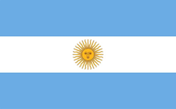
Argentina
“Hola”
Argentina was founded 9th July 1916 and covers an area of 2.7 million km². It is located in the continent of South America with an approximate population of 46.6 million. The capital city is Buenos Aires.
Argentina is the eighth largest country in the world by area, and the second largest in South America after Brazil. It has a long coastline along the Atlantic Ocean. Argentina has a rich history of immigration, especially from Europe, and a vibrant culture that blends indigenous, European, African, and Asian influences. It is known for its wine, cuisine, music, and sports.
Argentina is home to some of the worlds most iconic natural wonders, such as Iguazu falls, the Perito Moreno Glacier, Valdes Peninsula, and the Aconcagua the highest peak in the Americas. Argentina a destination for adventure seekers and wildlife lovers, with diverse regions and activities.

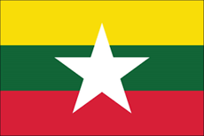
Burma
“Min Ga La Bar”
Myanmar (officially the Republic of the Union of Myanmar, also known as Burma (the official name until 1989). Burma was founded 4th January 1948. It is the largest country by area in Mainland Southeast Asia, and had a population of about 54 million in 2017. The capital city is Naypyidaw.
Myanmar (Burma) is simply amazing. This country of 55 million is rapidly emerging from more than 50 years of military dictatorship, blossoming into as worthy a stop as its popular neighbours
Famous landmarks include Shwedagon Pagoda (Yangon), Mount Popa and Golden Rock Stupa (Kyaiktiyo) and Grand Father Beach.

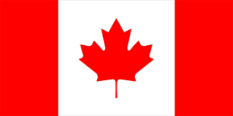
Canada
“Hello”
Canada is the second largest country in the world, but one of the most sparsely populated, with only 4 people per square kilometre. It was founded 1st July 1867 and covers an area of 9.9 million km². It is in the continent of North America with an approximate population of 39.2 million. The capital city is Ottawa.
Canada is a bilingual country, with English and French as official languages, and a multicultural country, with over 200 ethnic groups and 60 Indigenous peoples.
Canada is a leader in science and innovation, with achievements such as insulin, the telephone, the electric wheelchair, and the Canadarm for space exploration.
Canada is rich in natural resources, such as oil, natural gas, uranium, and maple syrup, and has diverse landscapes, such as mountains, forests, lakes, and glaciers.
Is a friendly and welcoming country, with a reputation for peacekeeping, humanitarianism, and cultural diversity, and a popular destination for tourists and immigrants.

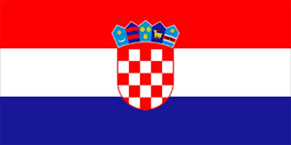
Croatia
“Pozdrav”
Croatia, officially the Republic of Croatia. It is a country at the crossroads of Central and Southeast Europe. Its coast lies entirely on the Adriatic Sea. It borders Slovenia to the northwest, Hungary to the northeast, Serbia to the east, Bosnia and Herzegovina and Montenegro to the southeast, and shares a maritime border with Italy to the west and southwest. Its capital and largest city, Zagreb, forms one of the country's primary subdivisions, with twenty counties. The country spans 56,594 square kilometres (21,851 square miles) and has a population of nearly 3.9 million.
With 2500 miles of coastline and close to 1200 islands, Croatia's sun-drenched credentials are impressive – and that's before you add its troves of Roman and Venetian-era architecture, Unesco sites of cultural and natural heritage, and gorgeous nature parks, mountain ranges, lakes and rivers.
If your Mediterranean fantasies feature balmy days by sapphire waters in the shade of ancient walled towns, Croatia is the place to turn them into reality.

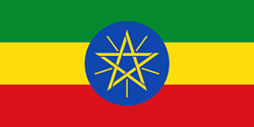
Ethiopia
“Salam”
It was founded 21st August 1995 and covers an area of 1.1 million km². It is located in the continent of Africa with an approximate population of 114 million, make Ethiopia the second most populous country in Africa and the 12th in the world.
Ethiopia is a landlocked country in the Horn of Africa, with a rich and diverse cultural heritage. It is the oldest independent country in Africa and one of the oldest in the world, dating back to the 10th century BC.
It is the birthplace of coffee and the home of the Ethiopian Orthodox Church, one of the oldest Christian denominations. It is also the source of the Blue Nile, which contributes most of the water to the Nile River, the longest in the world.

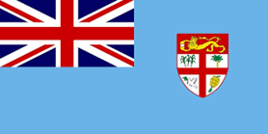
Fiji
“Bula”
Officially the Republic of Fiji. It was founded 10th October 1970.
Fiji is an island country in Melanesia, part of Oceania in the South Pacific Ocean. It lies about 1,100 nautical miles (2,000 km) north-northeast of New Zealand. Fiji consists of an archipelago of more than 330 islands—of which about 110 are permanently inhabited—and more than 500 islets, amounting to a total land area of about 18,300 square kilometres (7,100 sq mi). The most outlying island group is Ono-i-Lau. About 87% of the total population of 924,610 live on the two major islands, Viti Levu and Vanua Levu. About three-quarters of Fijians live on Viti Levu's coasts: either in the capital city of Suva; or in smaller urban centres such as Nadi—where tourism is the major local industry; or in Lautoka, where the sugar-cane industry is dominant. The interior of Viti Levu is sparsely inhabited because of its terrain.
With 333 unique islands across the heart of the South Pacific, Fiji can fulfil every tropical fantasy. Bouma’s hidden waterfalls, Cloudbreak’s world-class surf, or Rakiraki’s dive scene.

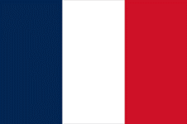
France
” Bonjour”
France was founded 22nd September 1792 and covers an area of 551.6 thousand km². Is primarily located in Western Europe with an approximate population of 64.6 million. The capital city is Paris.
France is a gastronomic wonderland, an artistic mecca, and a historical pop-up book. Vineyards blanket the wine regions, cathedrals crown the cities, and sandy beaches fringe the coastline. Famous landmarks include Eiffel Tower, Louvre Museum and Palace of Versailles.
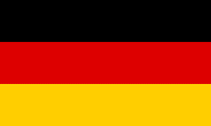
Germany
“Guten Tag”
Germany was founded 23rd May 1949. Germany is a large and diverse country in the heart of Europe, with a rich and turbulent history.
It emerged from a patchwork of kingdoms and principalities, unified by Prussia in the 19th century, and became a powerful empire. It was devastated by two world wars, divided by the Cold War, and reunited in 1990 after the fall of the Berlin Wall.
It is a leader in science, technology, culture, and diplomacy, and a key member of the EU and NATO.
It is famous for its natural beauty, cultural heritage, and festivals, such as Oktoberfest and Christmas markets.
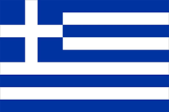
Greece
“YASSOH”
It was founded 3rd February 1830 and covers an area of 131.9 thousand km². It is located in the continent of Europe with an approximate population of 10.6 million.
Greece is a mosaic of islands and regions, each with its own distinctive character, traditions, cuisine, and attractions, from the iconic Santorini and Mykonos to the rugged Epirus and Crete.
Greece has endured centuries of foreign domination, from the Romans and Byzantines to the Ottomans and the Nazis but has always preserved its identity and spirit of resistance.
Greece is a land of ancient wonders, diverse cultures, and stunning landscapes, where history and modernity meet in the Mediterranean. The cradle of Western civilization, Greece boasts a rich heritage of philosophy, art, literature, and democracy, dating back to the Classical era of Athens, Sparta, and Delphi.

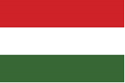
Hungary
“Szia”
It was founded 23rd March 1920 and covers an area of 93.0 thousand km². Hungary is a landlocked country in Central Europe, known for its rich history, culture, and thermal baths. Approximate population of 9.9 million. The capital city is Budapest.
The name Hungary comes from the word "Ungarii", which was used by Byzantine sources to refer to the Magyars, the ancestors of modern Hungarians.
Hungary was once part of the powerful Austro-Hungarian Empire, which collapsed after World War I and led to the loss of two-thirds of its territory and population.
Hungary became a communist state after World War II and faced a brutal Soviet intervention in 1956, when it tried to revolt against the regime. Hungary was one of the first countries to open its borders to the West in 1989, triggering the fall of the Iron Curtain and the end of the Cold War.
Hungary is a popular tourist destination, with attractions such as the capital Budapest, the largest lake in Central Europe, Lake Balaton, and the UNESCO World Heritage sites of Hollókő and Hortobágy.

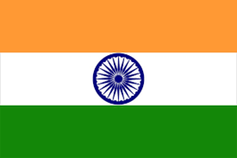
India
“Namaste”
It was founded 18th July 1947 and covers an area of 3.2 million km². India is a vast and diverse country that occupies most of South Asia and has a history of over 5,000 years. It is home to more than 1.3 billion people who speak hundreds of languages and practice various religions, cultures, and traditions.
It is the world’s largest democracy and a constitutional republic with a parliamentary system and a federal structure. It is also a major economic, political, and cultural power that has made significant contributions to science, technology, arts, literature, and sports.
It is known for its rich and varied heritage, including ancient civilizations, monuments, temples, festivals, cuisine, music, dance, and cinema. It is a land of contrasts and contradictions, where ancient and modern, rural and urban, poverty and prosperity, and diversity and unity coexist.

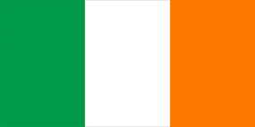
Ireland
“Dia Duit”
It was founded 29th December 1937 and covers an area of 84.4 thousand km^{2.} Ireland is a green island in the Atlantic, divided into the Republic of Ireland and Northern Ireland, part of the UK.
Ireland has a rich history of ancient monuments, medieval castles, and cultural heritage, dating back to the Celts and Vikings.
Ireland is famous for its scenic landscapes, such as the rugged cliffs of the Wild Atlantic Way, the rolling hills of the Hidden Heartlands, and the lush valleys of the Ancient East. Ireland is also a modern and vibrant country, with cosmopolitan cities like Dublin and Belfast, offering art, music, literature, and nightlife. Ireland is a destination for adventure seekers, who can enjoy hiking, cycling, surfing, kayaking, and golfing, among other activities.
Ireland is a place of legends, myths, and stories, where you can explore the sites of Game of Thrones, the tales of leprechauns and fairies, and the legacy of famous writers and poets.

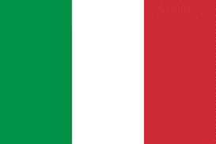
Italy
“Ciao”
It was founded 2nd June 1946 and covers an area of 301.2 thousand km². Italy is a boot-shaped country in south-central Europe, with a rich and diverse cultural heritage that spans millennia.
It has more Unesco world Heritage sites than any other country, from Ancient Roman ruins, Byzantine Mosaics and Renaissance Frescoes. It is also famous for its cuisine, which varies by region and reflects its history of invasions, migrations and trade. Pasta, pizza, cheese, wine and gelato are some of its iconic dishes.
Italy is also known for its artistic and scientific achievements, its fashion and design industry, its sports and entertainment icons, and its influence on global culture and politics.
Italy is a popular tourist destination, offering stunning landscapes, vibrant cities, charming villages and a variety of activities, from skiing in the Alps to sunbathing in the Mediterranean Coast.
offering stunning landscapes, vibrant cities, charming villages and a variety of activities, from skiing in the Alps to sunbathing on the Mediterranean coast.

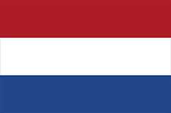
Netherlands
“Hallo”
It was founded 26th July 1581 and covers an area of 41.8 thousand km². Netherlands is a small but densely populated country in Northwestern Europe, with a rich history and culture, with an approximate population of 17.5 million. The capital city is Amsterdam.
The Netherlands is a diverse and tolerant society, where people speak multiple languages, enjoy a high quality of life, and celebrate their heritage and traditions
The country is known for the flat landscape, crisscrossed by canals, rivers and lakes, and dotted with Windmills, tulip fields and cheese markets.
. The Netherlands is also a leader in innovation, trade, and environmental sustainability, and a founding member of NATO and the EU. It was one of the first countries to adopt the euro as its currency in 1999.
The Netherlands offers a variety of attractions for tourists, from the cosmopolitan and artistic capital of Amsterdam, to the charming villages and historic sites of the countryside, to the sandy beaches and dunes of the coast.
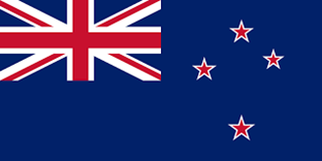
New Zealand
“Kia Ora”
The landscapes of The Lord of the Rings, glow worms, glaciers, penguins. New Zealand is one of those countries that has it all. In addition to its undoubted tourist attraction, Aotearoa, the land of the long white cloud, is unusual from start to finish, and has many unique facts, for example New Zealand was the first country in which the vote for women was approved in 1893. 30% of New Zealand is a national reserve, lots of green hills and forests full of lush vegetation. New Zealand also holds the record for the longest name for a town – Taumatawhakatangihangakoauauotamateaturipukakapikimaungahoronukupokaiwhenuakitanatahu – which translates to something like this: “The place where Tamatea, the man on the big knees who slipped, climbed and swallowed mountains, known as the land eater, he played the flute to his loved one”
There are more sheep than people in New Zealand – especially as there are quite a lot of Kiwi’s living in Wagin, and New Zealand was the last country in the world to be inhabited by humans – when the first Maori arrived around 800 years ago.

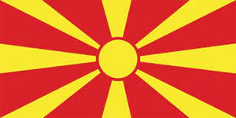
North Macedonia
“Dobar Den” (Good Day)
North Macedonia is a small Balkan country that changed its name in 2019 to end a decades-long dispute with Greece over the term "Macedonia".
North Macedonia is a parliamentary democracy that gained its independence from Yugoslavia in 1991, after a peaceful referendum. It is a candidate for joining the European Union and NATO.
The country has a rich and diverse cultural heritage, influenced by Greek, Roman, Ottoman, and Slavic civilizations, as well as its own ancient kingdom of Macedon. North Macedonia is home to Lake Ohrid, one of the oldest and deepest lakes in Europe, and a UNESCO World Heritage Site for its natural and cultural values.
North Macedonia has a friendly and cooperative relationship with the United States, which supports its political and economic reforms, security, and regional integration. North Macedonia is a popular destination for travellers who enjoy its scenic landscapes, historic towns, delicious cuisine, and hospitable people. However, it also has strict rules for exporting items of historical significance.

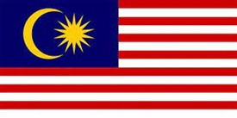
Malaysia
“Helo”
Malaysia is a diverse country of two regions: Peninsular Malaysia and East Malaysia on Borneo island, separated by the South China Sea.
Malaysia has a rich history of cultural, economic, and trade influences from China, India, the Middle East, and Africa, as well as colonial powers like Britain and Japan.
Malaysia is a major trading partner and ally of the U.S., with strong ties in security, environmental, and educational cooperation, as well as a growing digital economy and innovation sector.
Malaysia is home to the world's oldest rainforest, the largest cave chamber, and the highest peak in Southeast Asia, as well as a variety of wildlife and natural wonders, which makes Malaysia a popular tourist destination. Also known for its multicultural cuisine, vibrant cities, heritage sites, and scenic attractions, such as the Petronas Twin Towers, Mount Kinabalu, and Langkawi.

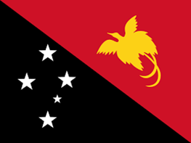
Papua New Guinea

“Monin or “Monin Tru” (a very good morning)
It was founded 1st July 1949 and covers an area of 462.8 thousand km². It is located as an island a part of Australia with an approximate population of 10.1 million. As of 2019, it is also the most rural, as only 13.25% of its people live in urban centres. Most of the population of more than 8 million people live in customary communities. Although government estimates have placed the country's population at 9.4 million. The capital city is Port Moresby.
At the national level, after being ruled by three external powers since 1884, including nearly 60 years of Australian administration starting during World War I, Papua New Guinea established its sovereignty in 1975. It became an independent Commonwealth realm in 1975 with Elizabeth II as its queen. It also became a member of the Commonwealth of Nations in its own right.
Home to a wide range of art, music, dance, and handicrafts. There's not much tourist infrastructure here but, as with its fellow Oceana Islands, visitors to PNG enjoy beaches, snorkelling, and its laid-back pace of life.

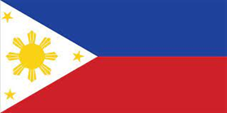
Philippines
“Kumusta”
It was founded 23rd January 1899 and covers an area of 300 thousand km².
The Philippines is a Southeast Asian archipelago of over 7,000 islands, with a rich and diverse history and culture.
It was colonized by Spain for more than 300 years, then by the US for almost 50 years, before gaining independence in 1946.
It is one of the most disaster-prone countries in the world, facing frequent earthquakes, volcanoes, and typhoons, as well as armed conflicts and insurgencies.
It is a major ally of the US in the region, with a mutual defence treaty and strong economic and cultural ties, but also has complex relations with China and other neighbours over territorial disputes and security issues.
It is a vibrant and colourful country, with a mix of influences from Malay, Chinese, Spanish, American, and indigenous cultures, reflected in its cuisine, music, art, and festivals. It is also one of the most biodiverse countries in the world, home to rare and endemic species of plants, animals, and marine life, such as the tarsier, the Philippine eagle, and the whale shark.

Poland
“CZESC”
It was founded some time in November 1918 and covers an area of 322.5 thousand km². Poland is a central European nation that has survived centuries of wars, invasions, and partitions, and has preserved its rich heritage and identity.
Poland is home to 16 UNESCO World Heritage Sites, including the medieval city of Kraków, the Auschwitz-Birkenau concentration camp, and the ancient salt mines of Wieliczka.

Is also known for its vibrant arts and music scene, with famous composers such as Chopin and Penderecki, and renowned filmmakers such as Polanski and Kieślowski. Poland has a diverse and delicious cuisine, influenced by its neighbors and history, featuring dishes such as pierogi, bigos, żurek, and kiełbasa.
Poland is a popular tourist destination, offering scenic landscapes, historic cities, cultural festivals, and outdoor activities, such as hiking, skiing, and kayaking.

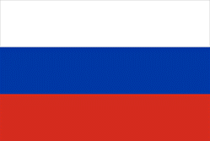
Russia
“Zdravstvute”
It was founded 25th December 1991. It is the largest country in the world, with its internationally recognised territory covering 17,098,246 square kilometres (6,601,670 sq mi), and encompassing one-eighth of Earth's inhabitable landmass. Russia extends across eleven time zones and shares land boundaries with fourteen countries. It is the world's ninth-most populous country and Europe's most populous country, with a population of over 147 million people. The country's capital and largest city is Moscow. Saint Petersburg is Russia's cultural centre and second-largest city. Other major urban areas include Novosibirsk, Yekaterinburg, Nizhny Novgorod, and Kazan.
The grandeur of the Czars, the brutality of Soviet regime, the literary masterpieces baring the Russian soul, and the onion domes of the cathedrals all have captivated the imagination of generations of travellers. Now Russia is shedding its Soviet past and creating itself a new. The palaces, cathedrals, and statues are all still there. But today's Russia is cynical and hip and full of contrasts. Trendy art galleries replaced the Soviet factories in many cities and fierce capitalism has created the wildly rich. More billionaires live in Moscow today than anywhere else, where restaurants, nightclubs and shops have taken luxury to a new level. In the new Russia, it seems anything is possible.

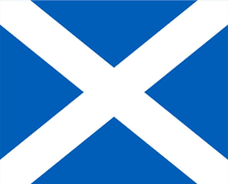
Scotland
“Alright”
It was founded 6th April 1320 and covers an area of 77.9 thousand km².
Scotland is part of the United Kingdom, but has its own devolved government, legal system, and education system, as well as a strong sense of national identity and pride.
Scotland is home to the Scots, a Celtic people who migrated from Ireland in the 5th century CE, and who have preserved their distinctive language, music, and traditions. Scotland is also a hub of innovation, creativity, and education, with world-class universities, research centres, and industries, as well as a thriving arts and cultural scene.
Scotland is a land of stunning natural beauty, rich history, and vibrant culture, where you can explore ancient castles, lochs, and mountains. Scotland is a popular destination for tourists, who can enjoy a range of activities, from hiking and golfing, to whisky tasting and festivals, to visiting film and TV locations.

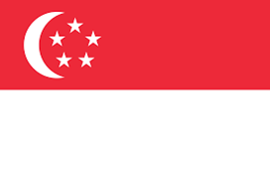
Singapore
“Nihao” (How are you)
It was founded 9th August 1965. Singapore, city-state located at the southern tip of the Malay Peninsula, about 85 miles (137 kilometres) north of the Equator. It consists of the diamond-shaped Singapore Island and some 60 small islets; the main island occupies all but about 18 square miles of this combined area.
Singapore is the largest port in Southeast Asia and one of the busiest in the world. It owes its growth and prosperity to its focal position at the southern extremity of the Malay Peninsula, where it dominates the Strait of Malacca, which connects the Indian Ocean to the South China Sea. Once a British colony and now a member of the Commonwealth, Singapore first joined the Federation of Malaysia on its formation in 1963 but seceded to become an independent state on August 9, 1965.
A country with one of the least stringent entry requirements, Singapore is home to a diverse population with a mix of Chinese, Malay and Indian influences along with a tropical climate.
One of the most popular travel destinations, Singapore is well known for its skyscrapers and modern lifestyle. Major attractions include Marina Bay Sands Singapore, Gardens by the Bay, Singapore Botanic Gardens, and the world-famous Universal Studios.

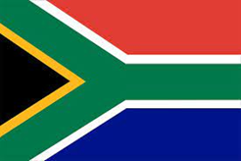
South Africa
“Heita”
It was founded 31st May 1961 and covers an area of 1.2 million km². It is located in the continent of Africa with an approximate population of 60.6 million.
South Africa is a diverse and beautiful country with 11 official languages and a rich cultural heritage. It is the southernmost country on the African continent and has a varied topography, climate, and wildlife.
South Africa is a parliamentary republic with a president as the head of state and a multi-party system. It is also known for its history of apartheid, a system of racial segregation and oppression that ended in 1994.
It has a mixed economy with a high level of inequality and poverty, but also a vibrant and innovative culture and society.
It is a popular destination for tourists who want to experience its natural wonders, wildlife, cities, and culture.

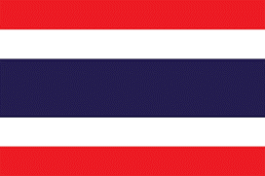
Thailand
- “In Thailand, men say hello with the following phonetic phrase: sah wah dee khrap! (short and sharp finish)
- Women say hello with: sah wah dee khaa… (drawn out finish)

It was founded sometime in 1238. The country is bordered to the north by Myanmar and Laos, to the east by Laos and Cambodia, to the south by the Gulf of Thailand and Malaysia, and to the west by the Andaman Sea and the extremity of Myanmar. Thailand also shares maritime borders with Vietnam to the southeast, and Indonesia and India to the southwest. Bangkok is the nation's capital and largest city.
Thailand conjures images of white sand beaches and cerulean waters, peaceful temples, and lush mountain jungles. In Bangkok, a 21st-century playground, the scent of spicy street food fills the air, and the Grand Palace recalls the country's traditions. Outside the capital, the wonders of the countryside enchant, whether you are elephant trekking in the northern hills, exploring Ayutthaya’s splendid ruins, or diving in the waters of the idyllic southern coast. The unique spirit of the Thai people—this is the “land of smiles,” after all—adds warmth to any visit.

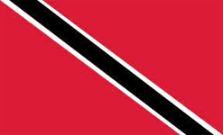
Trinidad and Tobago
“Hello”
It was founded 31st August 1962 and covers an area of 5.1 thousand km². It is located as an island a part of South America with a population of 1.5 million. The capital city is Port of Spain.
Trinidad and Tobago are a twin-island nation in the Caribbean, with diverse cultural influences and rich natural resources. The country is the birthplace of steel pan, a musical instrument made from oil barrels, and calypso, a rhythmic style of singing. Trinidad and Tobago is also known for its vibrant festivals, such as Carnival, Diwali, and Eid, which reflect its multicultural heritage and religious diversity.
The country has a thriving energy sector, exporting oil, gas, and petrochemicals to the world. It is also a regional leader in the Caribbean Basin Security Initiative.

Trinidad and Tobago boast of diverse wildlife and ecosystems, from coral reefs and mangroves to rainforests and mountains. It is home to the world's largest natural asphalt lake, Pitch Lake. However, the country also faces challenges such as crime, terrorism, and kidnapping, and travellers are advised to exercise caution and avoid certain areas.

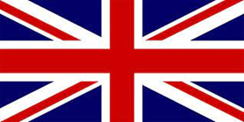
United Kingdom
“Hello”
United Kingdom was founded sometime in 1922 and covers an area of 243.6 thousand km². It is in the continent of Europe with a population of 67.5 million. The capital city is London.
The United Kingdom is a union of four nations: England, Scotland, Wales, and Northern Ireland, each with its own history, culture, and identity. The UK is a founding member of the Commonwealth, a voluntary association of 54 countries that share values of democracy, human rights, and cooperation.
The UK was once the centre of a vast empire that spanned a quarter of the world's land and influenced global politics, trade, and culture for centuries. The UK is a parliamentary democracy with a constitutional monarchy, where the King is the head of state and the Prime Minister is the head of government. The UK is a close ally of the United States, sharing a "special relationship" based on common history, language, and interests, as well as strong economic and security ties.
The UK is a diverse and multicultural society, with a rich heritage of literature, art, music, and science, as well as a vibrant modern culture of media, fashion, and sports.

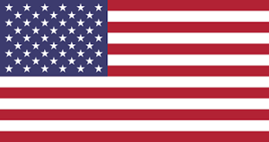
United States
USA was founded 4th July 1776 and covers an area of 9.8 million km². It is located in the continent of North America with a population of 334.2 million. The capital city is Washington, D.C. It consists of 50 states, a federal district, five major unincorporated territories, nine Minor Outlying Islands, and 326 Indian reservations.
From coast to coast, the United States of America has something for everyone. Visitors to the East Coast can catch a Broadway show in dazzling New York City or take a drive through the historic towns in New England. The South offers picturesque plantations in the Carolinas and Georgia, great food in New Orleans, and white sand beaches in Florida. The Midwest has sweeping prairie vistas and the great lakes, while the west is home to the awe-inspiring Rocky Mountains. On the West Coast, explore wine country, ancient forests, and everything sunny California has to offer. As if that's not enough, Alaska and Hawaii both offer adventure and majestic beauty in two locales that could not be more different. From mountains and oceans to deserts and meadows, from sprawling cities of towering skyscrapers to villages with roots still firmly planted in the past, the U.S.A. cannot be summed up easily.

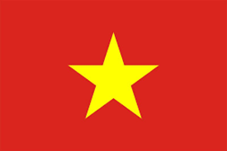
Vietnam
“Xin Chao”
It was founded 2nd September 1945 and covers an area of 331.2 thousand km². It is located in the continent of Asia with an approximate population of 98.5 million. Its capital is Hanoi and its largest city is Ho Chi Minh City (commonly referred to by its former name, Saigon).
Vietnam went through prolonged warfare in the 20th century. After World War II, France returned to reclaim colonial power in the First Indochina War, from which Vietnam emerged victorious in 1954. As a result of treaties signed two years later, Vietnam was also separated into two parts.
A developing country with a lower-middle-income economy, Vietnam is nonetheless one of the fastest-growing economies of the 21st century.
The natural beauty and unique culture have made Vietnam become a tourist destination worldwide. Spectacular nature, Exceptional cuisine, cultural diversity and Excellent service.

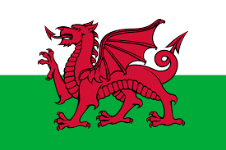
Wales
“Helo”
It was founded sometime in 1056 and covers an area of 20.7 thousand km². Wales is a country in the UK with a rich Celtic heritage and a distinctive language spoken by about a fifth of its population, with an approximate population of 3.2 million. The capital city is Cardiff.
It has six regions, each with its own character and attractions, from the rugged central heartland to the industrial South Wales and the scenic Welsh borderland.
Wales has a strong cultural identity, with a vibrant music and arts scene, a rich literary tradition, and a history of resistance and rebellion against English rule.
Wales is known for its natural beauty, with three national parks, five areas of outstanding natural beauty, and over 1,000 miles of coastline. Wales is also a land of adventure, with world-class trails and bike parks, zip lines and surf lagoons, and the highest mountain in England and Wales, Snowdon. Not forgetting the home of the legendary singer Sir Tom Jones.

