Wagin CommuniTEA Hub

Intentional connection, meaningful encouragement, and expanded friendships is the basis for a weekly social connection in Wagin, open to all.

Over coffee and refreshments for three hours, we talk and care and share, listening to each other’s oral histories and personal stories. Together we are ‘talking books’ – of wisdom, philosophy, perseverance, humour, and companionship.

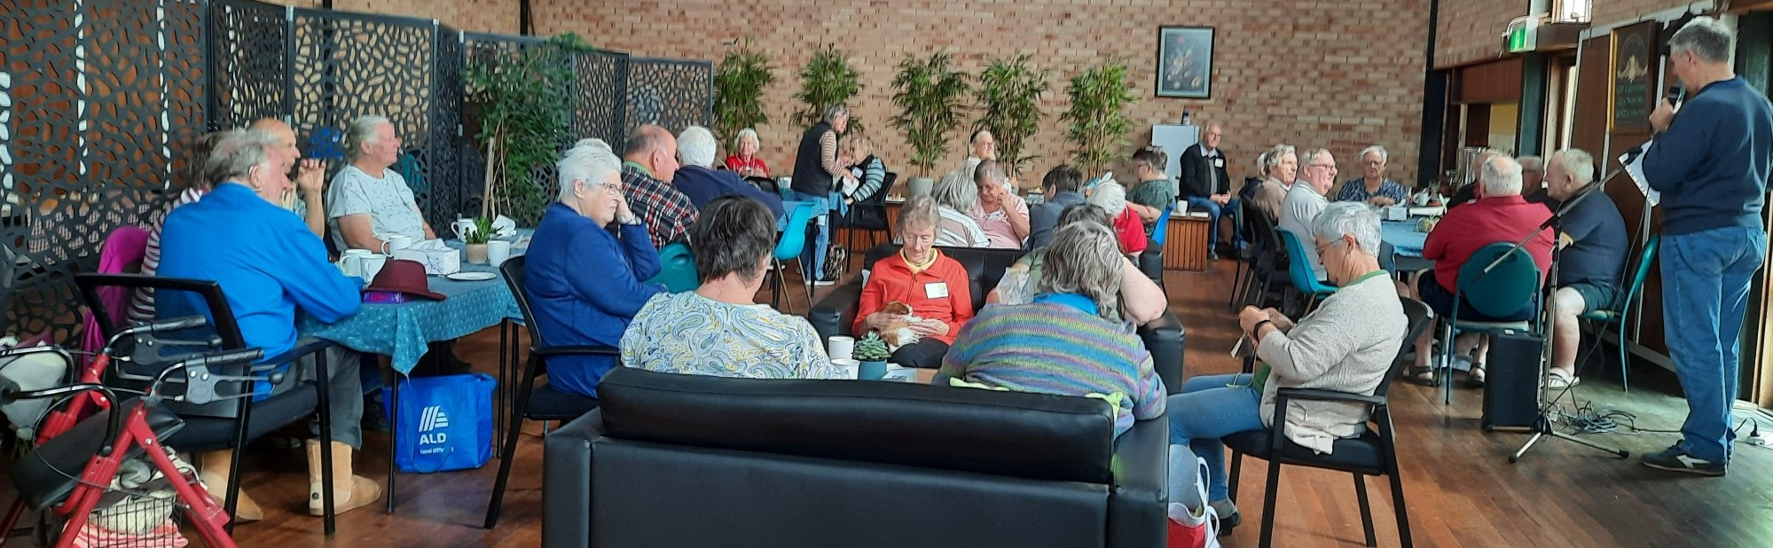

Those who attend are mostly of the 55+ age group, largely because the event is held on a weekday – Thursdays from 10am – but anyone over 20 is welcomed. The venue is Wesley Hall (corner of Ranford and Tavistock Streets) and entry is a gold coin donation. Tagged as “Conversation, Coffee and Cake”, Wagin CommuniTEA Hub meets a need for socialisation and support.

With the desire to serve the community of Wagin, the Uniting Church initiated the CommuniTEA Hub as a forum for strengthening people by validating them, celebrating the milestones, enabling people to remain effective, and to provide a safe place of belonging and caring. Run by volunteers, who believe that by affirming life we all grow and expand, the Hub regularly attracts 35 to 45 people.

For more information contact Wendy Pederick (0429 171 676) or Ann-Britt and Graham Wasley (9861 1724)

